Food Ordering Behaviour and Consumer Trends

Chapter 1: INTRODUCTION
1.1 Project Overview
Food Ordering Behaviour and Consumer Trends: A Structured Analysis of Choices and Habits
The rapid growth of online food delivery platforms has transformed the way customers order meals, creating vast amounts of transactional data every day. Understanding this data is essential for restaurants and food delivery companies to identify customer preferences, improve operational efficiency, and make informed business decisions. However, extracting meaningful insights from large datasets can be challenging without effective analytical tools.
This project focuses on analyzing food ordering behaviour using Tableau, a leading business intelligence and data visualization platform. The analysis is performed on a dataset containing 50,000 food orders with 19 attributes, including Order ID, Order Value, Delivery Fee, Cuisine, Meal Type, Restaurant Type, Customer Age, City, Delivery Time, and Customer Rating.
The project transforms raw data into interactive visualizations that highlight customer ordering patterns, cuisine preferences, city-wise demand, revenue contribution, and delivery performance. A comprehensive dashboard and an interactive story have been developed to present these insights in a clear and user-friendly manner. The analysis enables stakeholders to identify high-performing cities, popular cuisines, peak ordering periods, and operational bottlenecks, supporting better strategic planning and customer service improvements.

1.2 Purpose
The primary purpose of this project is to analyze customer food ordering behaviour and convert raw transactional data into meaningful business insights using Tableau. Through interactive dashboards and visual storytelling, the project helps understand customer preferences, ordering trends, and delivery performance while enabling data-driven decision-making.
The project is designed to achieve the following objectives:
- Analyze food ordering patterns across different cities and customer segments.
- Identify the most preferred cuisines and meal types.
- Compare order distribution among different restaurant categories.
- Evaluate revenue generated by various meal types.
- Study customer ratings to understand satisfaction levels.
- Examine delivery time distribution to identify operational efficiency.
- Develop an interactive Tableau dashboard with filters for dynamic analysis.
- Create a Tableau Story that presents insights in a logical sequence for business users.
By converting complex datasets into easy-to-understand visualizations, the project assists business analysts, operations managers, and decision-makers in improving customer experience, optimizing delivery services, and increasing overall business performance.

CHAPTER 2: IDEATION PHASE
2.1 Problem Statement
The rapid growth of online food delivery platforms has generated a large volume of customer and order data. While this data contains valuable insights, it is often underutilized due to the lack of effective analytical methods. Businesses face challenges in understanding customer preferences, identifying high-demand cuisines, analyzing city-wise order trends, and evaluating delivery performance. Without proper visualization and analysis, it becomes difficult to make informed decisions that improve customer satisfaction, optimize operations, and increase revenue.
This project addresses these challenges by leveraging Tableau to transform raw food ordering data into interactive dashboards and visual stories. The analysis helps identify ordering patterns, customer behavior, cuisine demand, revenue contribution, and delivery efficiency, enabling businesses to make data-driven decisions and enhance overall performance.

2.2 Empathy Map Canvas
Stakeholder: Food Delivery Platform
The empathy map helps understand the expectations, concerns, and behaviors of the primary stakeholders involved in the food ordering ecosystem.
SAYS | THINKS
"Customers expect quick delivery." | How can delivery time be reduced?
"Popular cuisines should always be available." | Which cuisines generate the highest demand?
"Business decisions should be based on data." | Which cities contribute the most revenue?
"Customer satisfaction is our  priority." | How can customer loyalty be improved?
DOES | FEELS
Monitors order trends and customer ratings. | Concerned about delivery delays.
Tracks city-wise demand and operational performance. | Motivated to improve service quality.
Uses dashboards to monitor KPIs. | Satisfied when customers receive timely service.
Optimizes resources based on demand. | Confident when decisions are supported by analytics.

Pain Points
- Difficulty identifying customer ordering patterns.
- Delivery delays during peak hours.
- Limited visibility into city-wise demand.
- Challenges in tracking cuisine popularity and revenue contribution.

Goals
- Improve delivery efficiency.
- Enhance customer satisfaction.
- Increase revenue through data-driven decisions.
- Identify business growth opportunities.
- Optimize operational performance using analytics.

2.3 Brainstorming
Before developing the Tableau dashboard, different analytical ideas were explored to determine the most valuable insights that could be extracted from the dataset. The brainstorming process focused on identifying business questions that would help improve customer experience and operational efficiency.
The following questions guided the analysis:
- Which age group places the highest number of food orders?
- Which restaurant category (Budget, Mid-range, Premium) receives the most orders?
- Which cuisines are most preferred by customers?
- How does cuisine demand vary across different cities?
- Which meal type generates the highest revenue?
- Which cities have the highest order volumes?
- How do customer ratings differ across meal types?
- How is order distribution affected by company type and meal type?
- What is the distribution of delivery times across all orders?
- How can interactive filters improve business decision-making?
Based on these questions, the following visualizations were selected for the dashboard:
- KPI Cards
- Stacked Bar Chart
- Heat Map
- Pie Chart
- Donut Chart
- Horizontal Bar Chart
- Vertical Bar Charts
- Interactive Filters
- Tableau Story
These visualizations collectively provide a comprehensive understanding of food ordering behavior, customer preferences, revenue patterns, and operational performance, enabling stakeholders to make informed business decisions.

CHAPTER 3: REQUIREMENT ANALYSIS
This chapter identifies the business and technical requirements of the Food Ordering Behaviour Analysis project. It explains the customer journey, defines the functional and non-functional requirements, illustrates the flow of data within the system, and presents the technologies used to develop the Tableau dashboard.

3.1 Customer Journey Map
The Customer Journey Map illustrates the complete experience of a customer while using an online food delivery platform. Understanding this journey helps identify important interaction points that influence customer satisfaction and business performance.
Customer Journey
Stage | Customer Activity | Business Interaction
Discover | Opens the food delivery application | Displays restaurants and offers
Explore | Searches restaurants and cuisines | Recommends restaurants based on location
Select | Chooses food items and meal type | Calculates order value and delivery fee
Order | Places the order | Confirms order and processes payment
Prepare | Restaurant prepares the food | Updates order status
Deliver | Delivery partner picks up and delivers the order | Tracks delivery time and route
Receive | Customer receives the food | Marks order as completed
Review | Provides rating and feedback | Stores customer ratings for analysis
Key Observations
- Customer satisfaction depends heavily on delivery speed and service quality.
- Cuisine variety and meal options influence purchasing decisions.
- Customer ratings provide valuable feedback for improving services.
- Order history helps businesses identify customer preferences and future demand.

3.2 Solution Requirements
The proposed Tableau dashboard is designed to meet both business and analytical requirements by transforming raw food ordering data into meaningful visual insights.
Functional Requirements
The system should be able to:
- Import the CSV dataset into Tableau.
- Clean and organize the dataset for analysis.
- Generate calculated fields such as Age Group.
- Create interactive charts and dashboards.
- Display key performance indicators (KPIs).
- Allow users to filter data by city.
- Analyze cuisine preferences and meal types.
- Visualize revenue contribution.
- Analyze customer ratings.
- Display delivery time distribution.
- Publish dashboards to Tableau Public.
- Support dashboard integration with a Flask web application.

Non-Functional Requirements
The system should satisfy the following quality requirements:
Requirement | Description
Performance | Dashboard should load and respond quickly.
Reliability | All 50,000 records should be processed accurately.
Usability | Dashboard should be easy to understand and navigate.
Scalability | Capable of handling larger datasets with minimal modifications.
Maintainability | Easy to update with new datasets or visualizations.
Availability | Dashboard can be accessed online through Tableau Public.

3.3 Data Flow Diagram
The Data Flow Diagram (DFD) illustrates how data moves through the system, from dataset collection to dashboard generation and business insights.
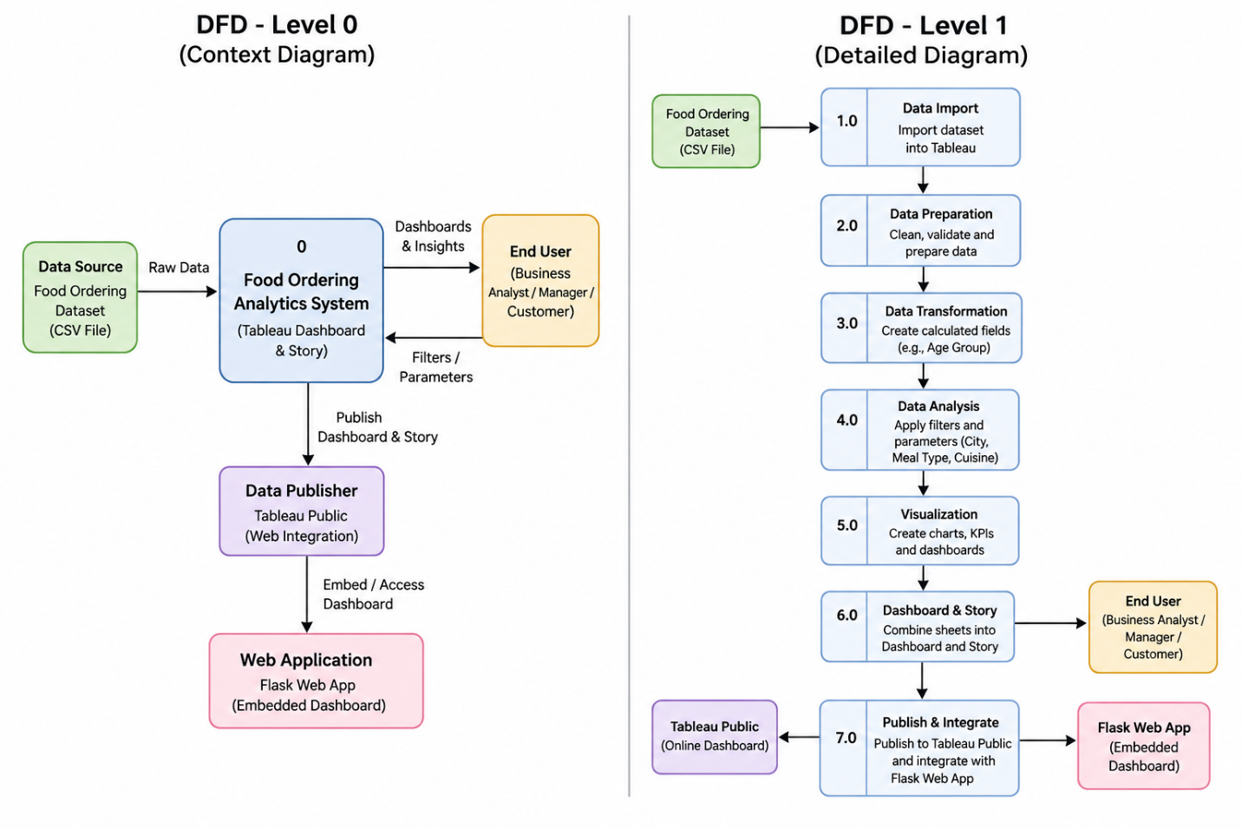
Description
The project begins by importing the food ordering dataset into Tableau. After data cleaning and transformation, calculated fields such as Age Group are created to simplify customer segmentation. Interactive filters enable users to explore the data dynamically. Multiple visualizations are combined into a dashboard and a Tableau Story, which together provide actionable insights into customer behaviour, cuisine demand, revenue generation, and delivery performance.

3.4 Technology Stack
The project uses modern business intelligence and web technologies to perform data analysis, visualization, and deployment.
Technology | Purpose
CSV Dataset | Stores food ordering data containing 50,000 records and 19 attributes
Tableau Desktop | Data visualization and dashboard creation
Tableau Public | Publishing dashboards and stories online
Flask | Web application framework for dashboard integration
HTML | Front-end webpage structure
Web Browser | Dashboard access and visualization

CHAPTER 4: PROJECT DESIGN
Project Design defines how the identified business problem is addressed through an analytical solution. It describes the relationship between the business challenges and the proposed Tableau-based solution, explains the system architecture, and outlines how data is transformed into meaningful business insights.

4.1 Problem Solution Fit
The increasing popularity of online food delivery services has resulted in the generation of large volumes of customer and order-related data. While this data contains valuable business information, organizations often struggle to extract actionable insights due to the complexity of analyzing raw datasets.
The proposed Tableau-based analytics solution addresses these challenges by converting raw transactional data into interactive visualizations and dashboards. The dashboard enables stakeholders to monitor customer preferences, cuisine demand, revenue generation, order distribution, and delivery performance through an intuitive interface.
Problem–Solution Fit Table
Business Problem | Proposed Solution
Large amount of raw food ordering data | Import and organize the dataset in Tableau for analysis
Difficulty identifying customer preferences | Visualize cuisine popularity and meal type trends
Limited understanding of city-wise demand | Create city-based dashboards and heat maps
Poor visibility of delivery performance | Analyze delivery time distribution using charts
Revenue trends are difficult to monitor | Display revenue contribution through KPI cards and bar charts
Static reports limit decision-making | Develop interactive dashboards with filters and stories

The solution bridges the gap between raw data and business intelligence by providing an easy-to-use platform for exploring food ordering behaviour and operational performance.

4.2 Proposed Solution
The proposed solution is an interactive Food Ordering Behaviour Analysis Dashboard developed using Tableau. The dashboard processes the food ordering dataset and presents key business metrics through multiple visualizations, allowing users to explore customer behaviour and operational trends.
The solution follows these stages:
- Import the food ordering dataset into Tableau.
- Clean and validate the dataset.
- Create calculated fields such as Age Group.
- Develop visualizations including KPI cards, bar charts, heat maps, pie charts, and donut charts.
- Combine individual worksheets into an interactive dashboard.
- Build a Tableau Story to present insights in a logical sequence.
- Publish the dashboard on Tableau Public.
- Integrate the published dashboard into a Flask web application for web-based access.
This solution enables business analysts, operations managers, and decision-makers to monitor food ordering trends, customer preferences, revenue contribution, and delivery performance in real time.

4.3 Solution Architecture
The solution architecture illustrates the complete flow of data from the source dataset to the end user.
Architecture Description
The project begins with a structured CSV dataset containing 50,000 food ordering records. The dataset is imported into Tableau, where it undergoes data preparation and analysis. Interactive worksheets are then created using various visualization techniques. These worksheets are combined into a comprehensive dashboard and Tableau Story. Finally, the dashboard is published to Tableau Public and embedded into a Flask web application, allowing users to access the analytics through a web browser.

Solution Architecture Flow
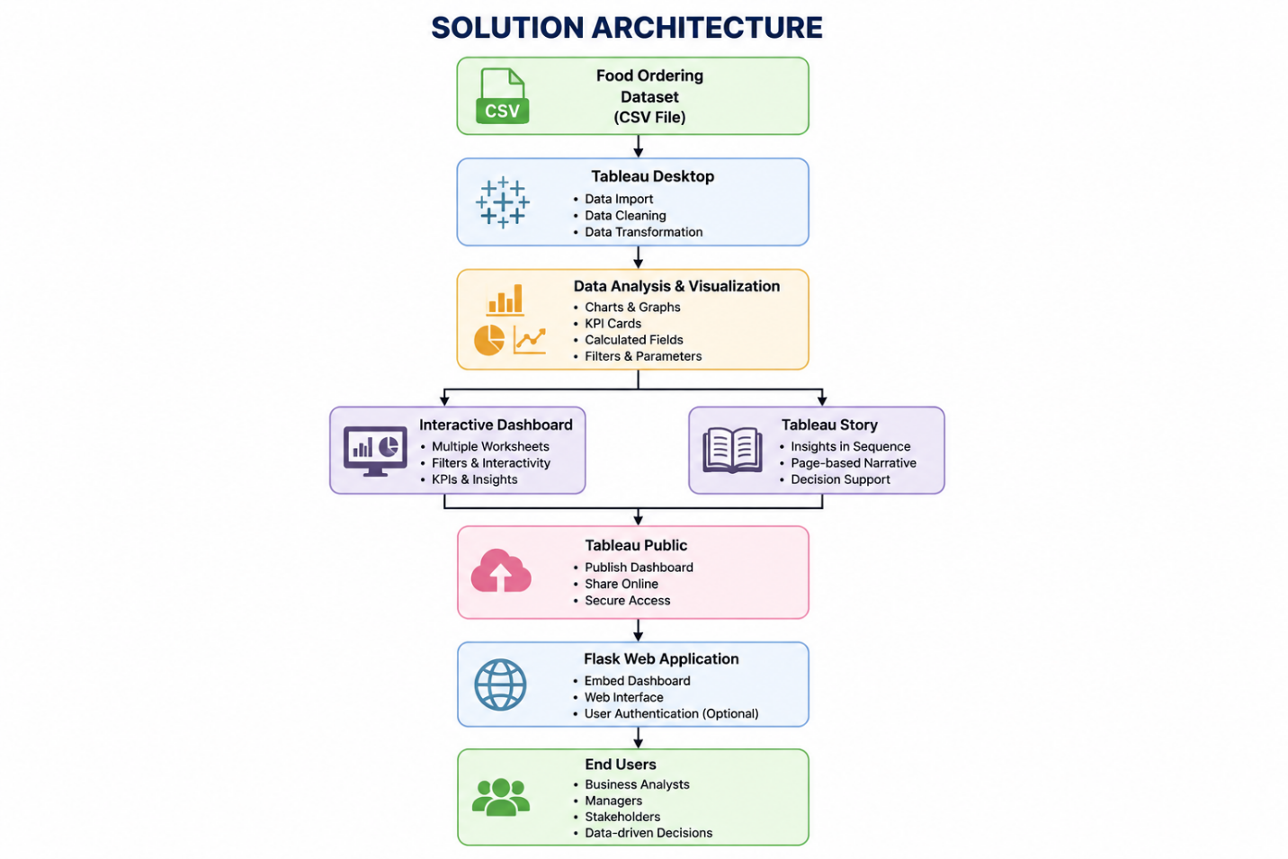

CHAPTER 5: PROJECT PLANNING & SCHEDULING
5.1 Project Planning
Project Planning
The project was planned using a structured development approach to ensure the successful completion of all stages within the allocated internship duration. The work was divided into phases including problem identification, requirement analysis, dashboard design, implementation, testing, and documentation.
Each phase had clearly defined objectives and deliverables. Regular reviews and testing were conducted to ensure the dashboard met the required functionality and accurately represented the food ordering data.

5.2 Project Schedule
Phase | Activities | Duration
Phase 1 | Problem Identification & Requirement Analysis | Week 1
Phase 2 | Dataset Collection & Data Preparation | Week 1
Phase 3 | Dashboard Design & Visualization | Week 2
Phase 4 | Story Creation & Dashboard Integration | Week 3
Phase 5 | Flask Integration & Deployment | Week 3
Phase 6 | Testing & Validation | Week 4
Phase 7 | Documentation & Final Submission | Week 4

5.3 Milestones
Milestone | Description | Status
M1 | Project Topic Finalization | ✓ Completed
M2 | Dataset Collection | ✓ Completed
M3 | Data Cleaning & Preparation | ✓ Completed
M4 | Dashboard Development | ✓ Completed
M5 | Tableau Story Creation | ✓ Completed
M6 | Flask Web Application Integration | ✓ Completed
M7 | Testing & Validation | ✓ Completed
M8 | Report Documentation | ✓ Completed

CHAPTER 6: FUNCTIONAL AND PERFORMANCE TESTING
6.1 Performance Testing
Performance testing was conducted to evaluate the efficiency, reliability, and responsiveness of the AI Resume Analyzer system under different usage conditions. The application was tested using multiple resume files with varying formats and content to ensure consistent performance. The system successfully analyzed resumes, extracted relevant information, calculated resume scores, and generated AI-based recommendations within a few seconds.
The testing results confirmed that the application provides accurate resume analysis while maintaining low response time and stable performance. No major functional issues or performance bottlenecks were observed during testing.
Performance Testing Table
Test Case | Expected Result | Actual Result | Status
Upload PDF Resume | Resume uploads successfully | Uploaded successfully | ✅ Pass
Upload DOCX Resume | Resume uploads successfully | Uploaded successfully | ✅ Pass
Extract Resume Details | Skills, education, and experience extracted correctly | Data extracted correctly | ✅ Pass
Resume Score Calculation | Resume score generated accurately | Score generated correctly | ✅ Pass
AI Suggestions | Personalized improvement suggestions displayed | Suggestions generated successfully | ✅ Pass
Job Role Recommendation | Relevant job roles recommended | Recommendations displayed correctly | ✅ Pass
Invalid File Upload | Error message displayed | Proper validation message shown | ✅ Pass
Multiple Resume Testing | System performs consistently | Stable performance observed | ✅ Pass

CHAPTER 7: RESULTS
7.1 Output Screenshots
The AI Resume Analyzer was successfully developed and tested. The application performs resume parsing, extracts relevant information, evaluates the resume based on predefined criteria, and generates AI-powered recommendations to improve the candidate's profile. The following screenshots demonstrate the successful execution of the system and its major functionalities.
Figure 7.1: KPI Cards
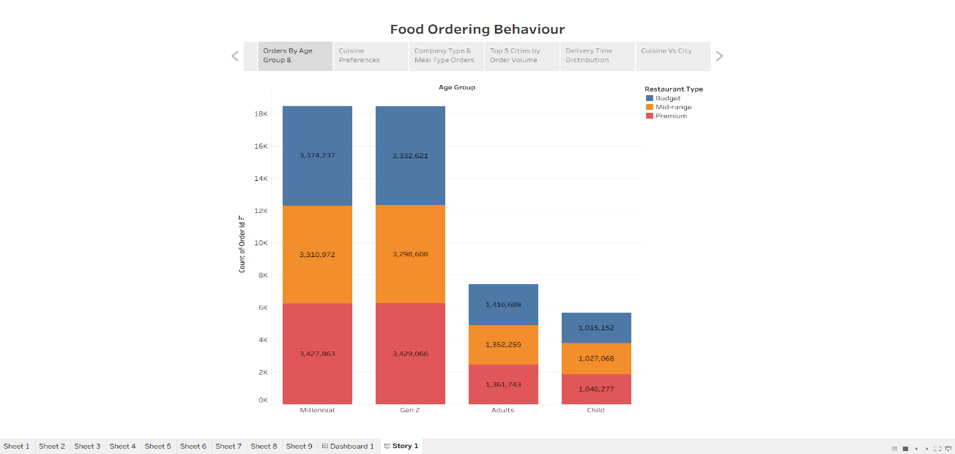
Figure 7.2: Heat Map – City vs Cuisine Demand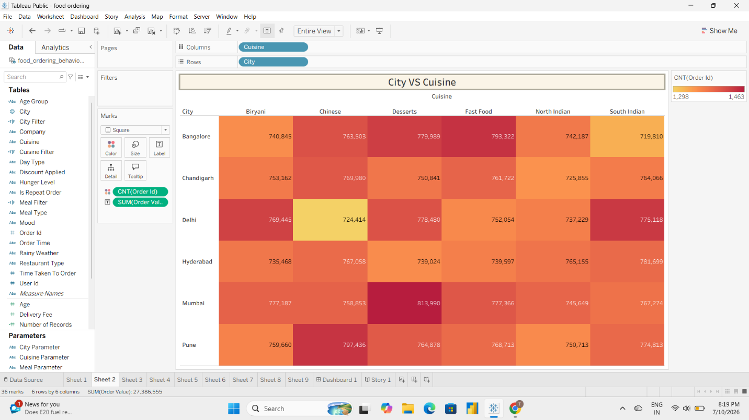

Figure 7.3: Grouped Bar Chart – Age Group vs Restaurant Type
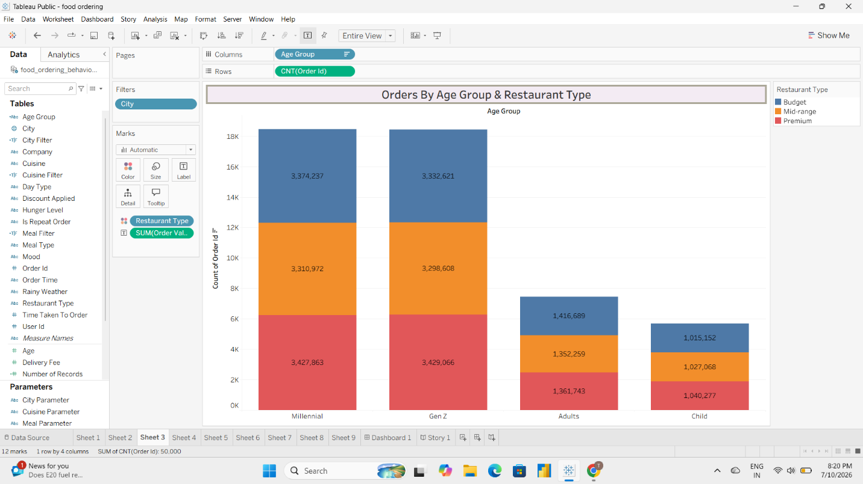

Figure 7.4: Pie Chart – Cuisine Preference Distribution
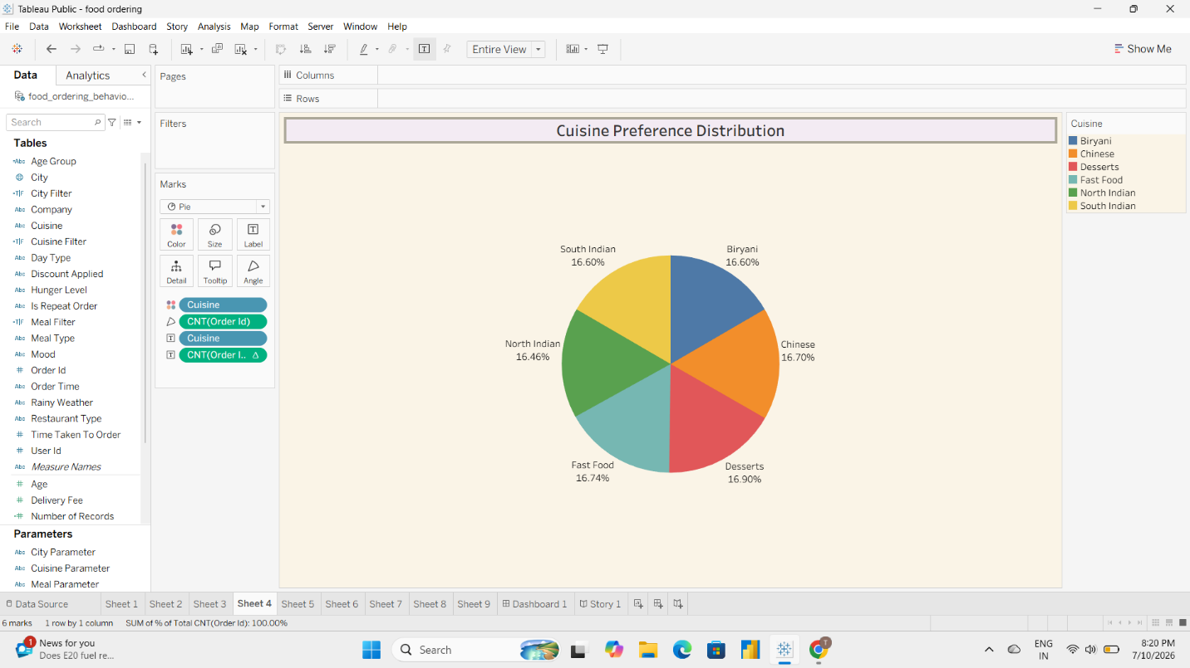

Figure 7.5: Bar Chart – Company Type vs Meal Type
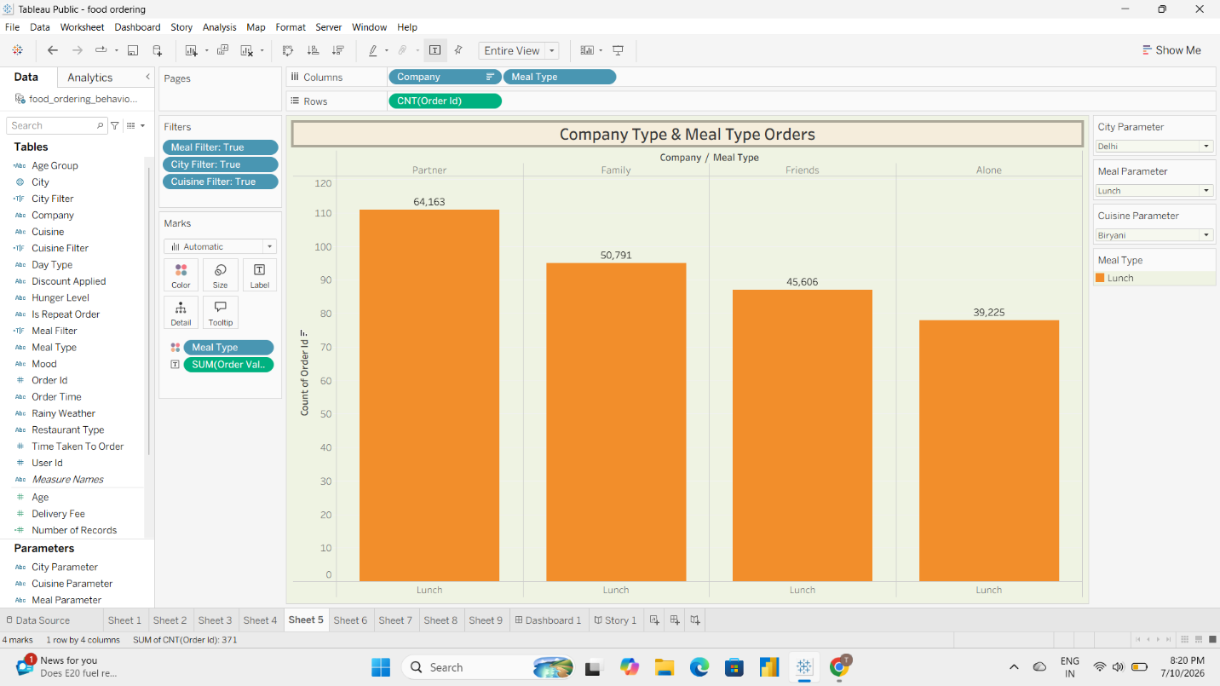

Figure 7.6: Donut Chart – Customer Rating by Meal Type
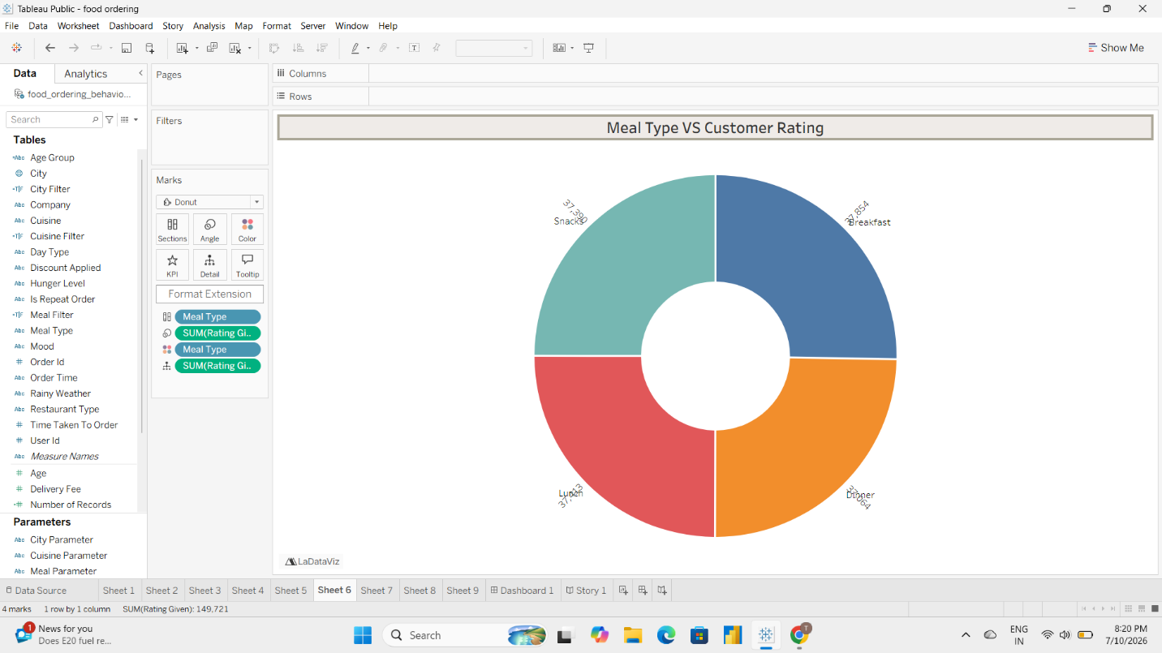

Figure 7.7: Bar Chart – Top 5 Cities by Order Volume
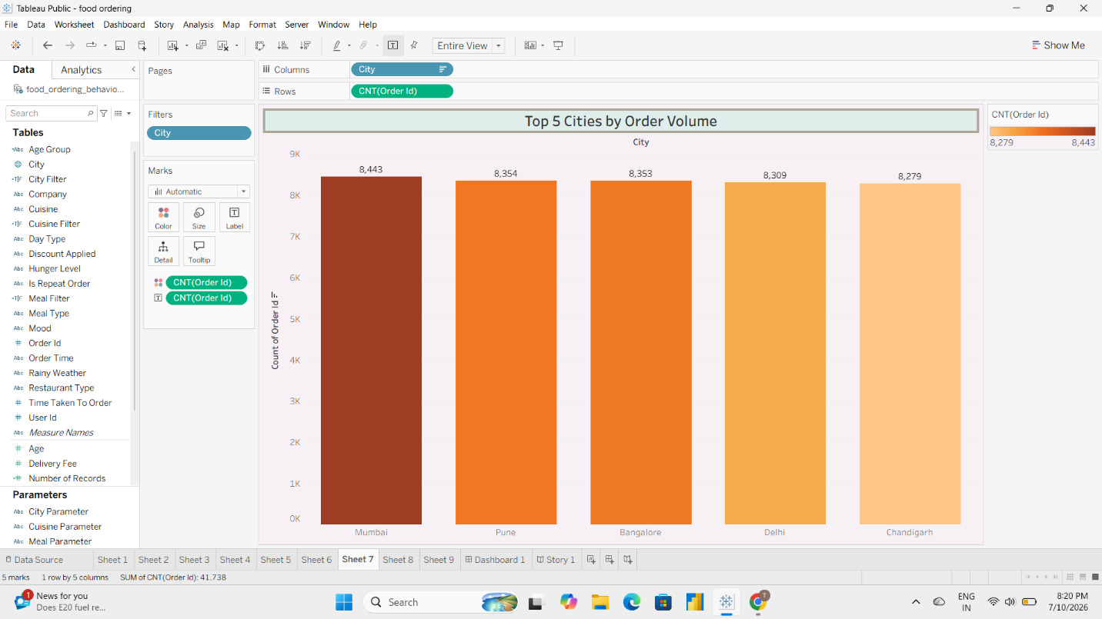

Figure 7.8: Bar Chart – Revenue Contribution by Meal Type
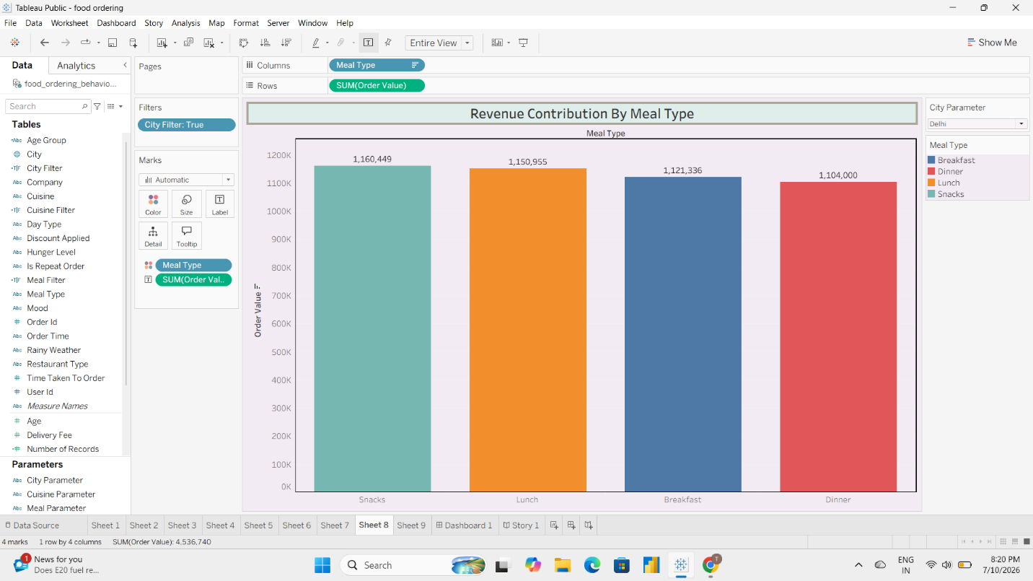

Figure 7.9: Horizontal Bar Chart – Delivery Time Distribution
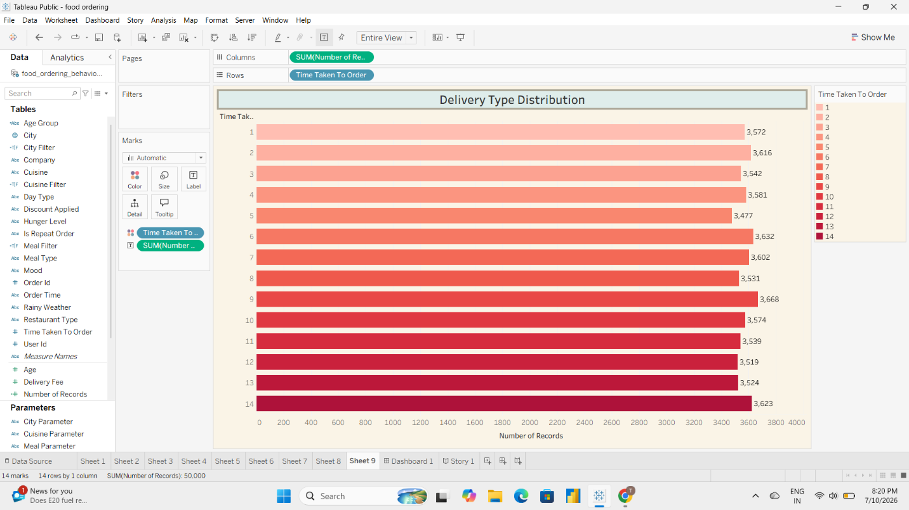

Figure 7.10: Complete Tableau Dashboard
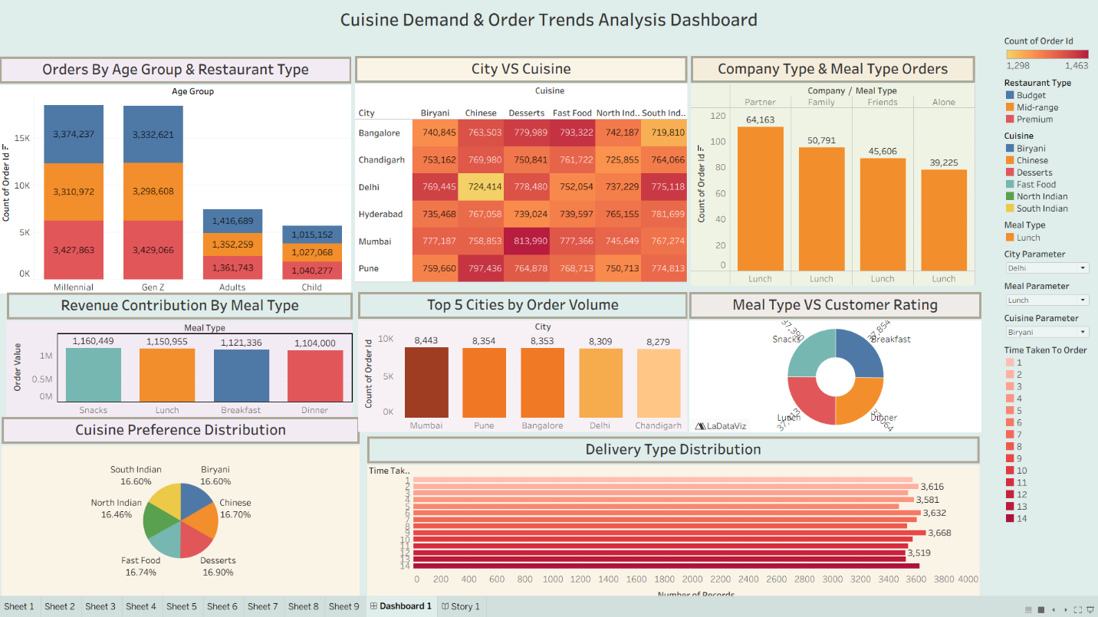

CHAPTER 8: ADVANTAGES & DISADVANTAGES
Advantages
The Food Ordering Behaviour Analysis Dashboard offers several benefits for businesses and decision-makers by transforming raw data into meaningful insights. The key advantages are as follows:
- Provides an interactive and user-friendly dashboard for analyzing food ordering behaviour.
- Enables businesses to identify popular cuisines, meal types, and customer preferences.
- Supports data-driven decision-making through visual analytics.
- Helps analyze city-wise order distribution and revenue contribution.
- Tracks customer ratings to evaluate service quality.
- Monitors delivery time distribution to identify operational bottlenecks.
- Interactive filters allow users to explore data based on cities and other attributes.
- Reduces the time required to analyze large datasets manually.
- Dashboard can be published on Tableau Public and accessed through a web browser.
- Can be integrated with a Flask web application for easy accessibility.

Disadvantages
Despite its advantages, the current implementation has a few limitations:
- The analysis is limited to the available historical dataset and does not include live data.
- Dashboard insights depend on the quality and accuracy of the input data.
- External factors such as weather, traffic, and seasonal demand are not considered.
- Real-time order tracking and predictive analytics are not implemented.
- The dashboard requires an internet connection when accessed through Tableau Public.
- User authentication and role-based access control are not included in the current version.

CHAPTER 9: CONCLUSION
The Food Ordering Behaviour and Consumer Trends: A Structured Analysis of Choices and Habits project successfully demonstrates how data visualization and business intelligence tools can transform raw data into meaningful insights. By utilizing Tableau, the project analyzes food ordering patterns, customer preferences, delivery performance, and revenue trends through interactive dashboards and stories.
The analysis identified valuable business insights such as the most preferred cuisines, high-performing cities, popular meal types, customer age group distribution, revenue contribution, and delivery time patterns. Interactive filters and visualizations enable users to explore the data dynamically, making it easier to understand customer behaviour and operational performance.
The developed dashboard serves as an effective decision-support tool for business analysts, operations managers, and other stakeholders. It helps organizations optimize their services, improve customer satisfaction, and make informed strategic decisions based on data.
Overall, the project successfully achieves its objectives by presenting complex food ordering data in a simple, interactive, and visually appealing manner. It highlights the importance of data analytics and visualization in enhancing business performance and supporting evidence-based decision-making.

CHAPTER 10: FUTURE SCOPE
Although the current dashboard provides comprehensive insights into food ordering behaviour, several enhancements can be incorporated in future versions to improve its functionality and business value.
Some potential future enhancements include:
- Integrating real-time food ordering data for live dashboard updates.
- Applying machine learning models to predict future order demand and customer preferences.
- Developing personalized food recommendations based on customer ordering history.
- Incorporating external factors such as weather conditions, festivals, and seasonal trends to improve demand forecasting.
- Implementing advanced analytics for customer segmentation and churn prediction.
- Enhancing the dashboard with additional interactive filters and drill-down capabilities.
- Developing a mobile-friendly version of the dashboard for improved accessibility.
- Integrating the solution with cloud platforms for better scalability and real-time data synchronization.
- Implementing role-based authentication to provide secure access for different users.
- Expanding the analysis by integrating customer feedback and sentiment analysis from online reviews.
These enhancements would further strengthen the analytical capabilities of the system and provide deeper insights for business growth, operational efficiency, and customer satisfaction.

CHAPTER 11: APPENDIX
The appendix contains the supplementary resources, source code references, dataset details, and project links used during the development of the Food Ordering Behaviour and Consumer Trends: A Structured Analysis of Choices and Habits project.
11.1 Dataset Details
Dataset Name
Food Ordering Behaviour Dataset
Dataset Format
CSV
Number of Records
50,000
Number of Attributes
19
Major Attributes
- Order ID
- Customer Age
- City
- Cuisine
- Meal Type
- Restaurant Type
- Company Type
- Order Value
- Delivery Fee
- Delivery Time
- Customer Rating
- Payment Method
- Order Date
- Order Time
- Discount Applied
- Quantity
- Occasion
- Platform
- Total Amount

11.2 Dataset Link
Dataset Link

11.3 GitHub Repository
Github Link

